|  |  |
| --- | --- |
| Platform Adventure  2.5 D Game | By Fabian, Aman, and Harshit  Document for the Demo version of the game. |

Character Selection:

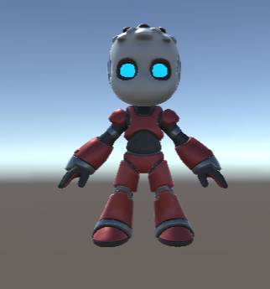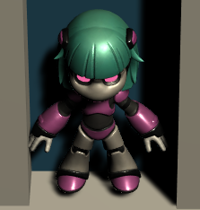

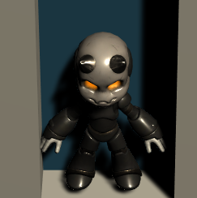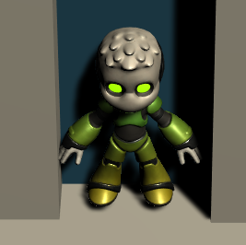

Level 1: Summer

Level 2: Winter

Level 3: Rain

Game Controls

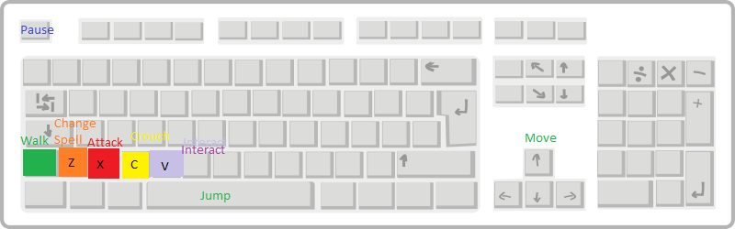

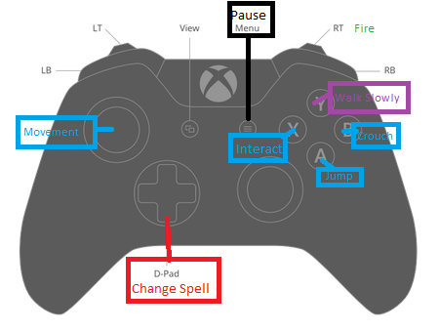

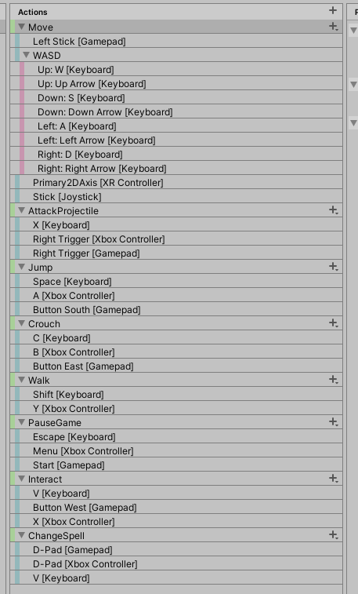

Copyright and Sources:

Tutorials and Help:

* Brackeys tutorials: <https://www.youtube.com/user/Brackeys/videos>
* <https://www.turbosquid.com/Search/Texture-Maps/free>
* Health Bar. Retrieved from <https://www.youtube.com/watch?v=BLfNP4Sc_iA&t=694s>
* Character Movement script based on standard assets Unity
* Documentation from Unity Website

**Projectile:**

* <https://www.youtube.com/watch?v=xenW67bXTgM&t=170s>
* <https://www.youtube.com/channel/UCtb1s859RTxx-RIgFs5ZVQA>

**Enemies:**

* <https://www.youtube.com/watch?v=xppompv1DBg>
* <https://www.youtube.com/watch?v=gXpi1czz5NA&t=543s>

**Spawning:**

* <https://www.youtube.com/watch?v=nBgCeJBMT0k&t=272s>

**Main menu background:**

* <https://wall.alphacoders.com/search.php?search=poly+forest>

**Main Menu text:**

* <https://fonts.adobe.com/fonts/liberation-sans>

**Inventory:**

* Killer Whale
* <https://www.youtube.com/watch?v=X-lW15kaZtM>

**Music and Sound Effects:**

* <https://www.youtube.com/watch?v=6OT43pvUyfY>
* Bensound.com
* <https://www.bensound.com/>
* Zapslat.com
* <https://www.zapsplat.com/sound-effect-categories/>
* Freesoundseffects.com
* <https://www.freesoundeffects.com/free-sounds/scary-and-horror-10085/40/tot_sold/20/3/>

**Screen ratio**

* <https://www.youtube.com/watch?v=YOaYQrN1oYQ>

Art assets:

* Animations: <https://www.mixamo.com/#/?page=1&query=run+left>
* Models - Animations Enemy, Button, and Lever by Fabian Condori
* ProBuilder for terrain
* Chibi Characters unity assets for main character and variants
* Mediebal weapons unity asset for weapons
* Gems Ultimate pack
* 2d Ice Platform Pack
* Key
* Traps prefab Assets
* BitGem Cubes Pack
* Creatures LowPoly Pack
* Assets store “Dungeon Traps”